INSERTION OF DRAIN TUBES (GROMMETS) IN EARS
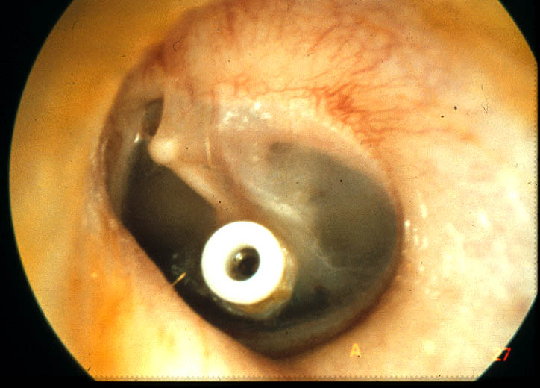

Instructions

Soluble Paracetamol or equivalent should be sufficient to control any ear ache following surgery. Do not be alarmed if there is any brown discharge from the ears on the first day post operation. Keep your child in doors for the first 24 hours and off school for 1 day.
Do not allow water to enter the ears when taking a bath or washing the hair. Protect the ears by placing a plug of cotton wool covered with Vaseline in the opening of the ear canal. Occasionally the child may complain of a sensation of popping, clicking or fullness in the ears, which is not harmful. In the event of the child having continuous discharge, bleeding or severe pain they should see their own doctor or telephone my secretary on 01296 315770 or 01527 66420.

Swimming and Grommets

Children should be allowed to go swimming. However, when they go in the water the ears should be plugged with cotton wool and Vaseline and protected by a bathing cap or an Ear Bandit ( a neoprene band that can be bought from hearing aid providers or Great Little Trading Company on line.. They should refrain from underwater swimming and diving. Many doctors and parents fail to realise that infection can spread via the nose and Eustachian tube even if the ear canals are well protected by customised ear plugs.

In the event of infection, it is advisable to wait until the ears have returned to normal function rather than risk recurrence or necessitate multiple operations.

Air Travel

The grommet bypasses the blocked Eustachian tube and thus equalises pressure in the middle ear. Therefore it is safe to travel by air

